**Step1.** Open Envelope and you should write user and password for login

THE UNIVERSITY OF SINDH

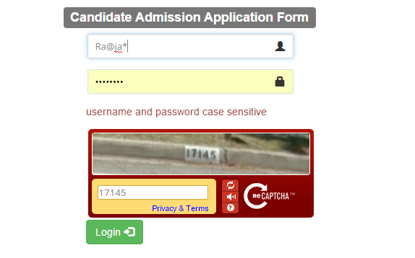

**Step2. Write down your personal information**

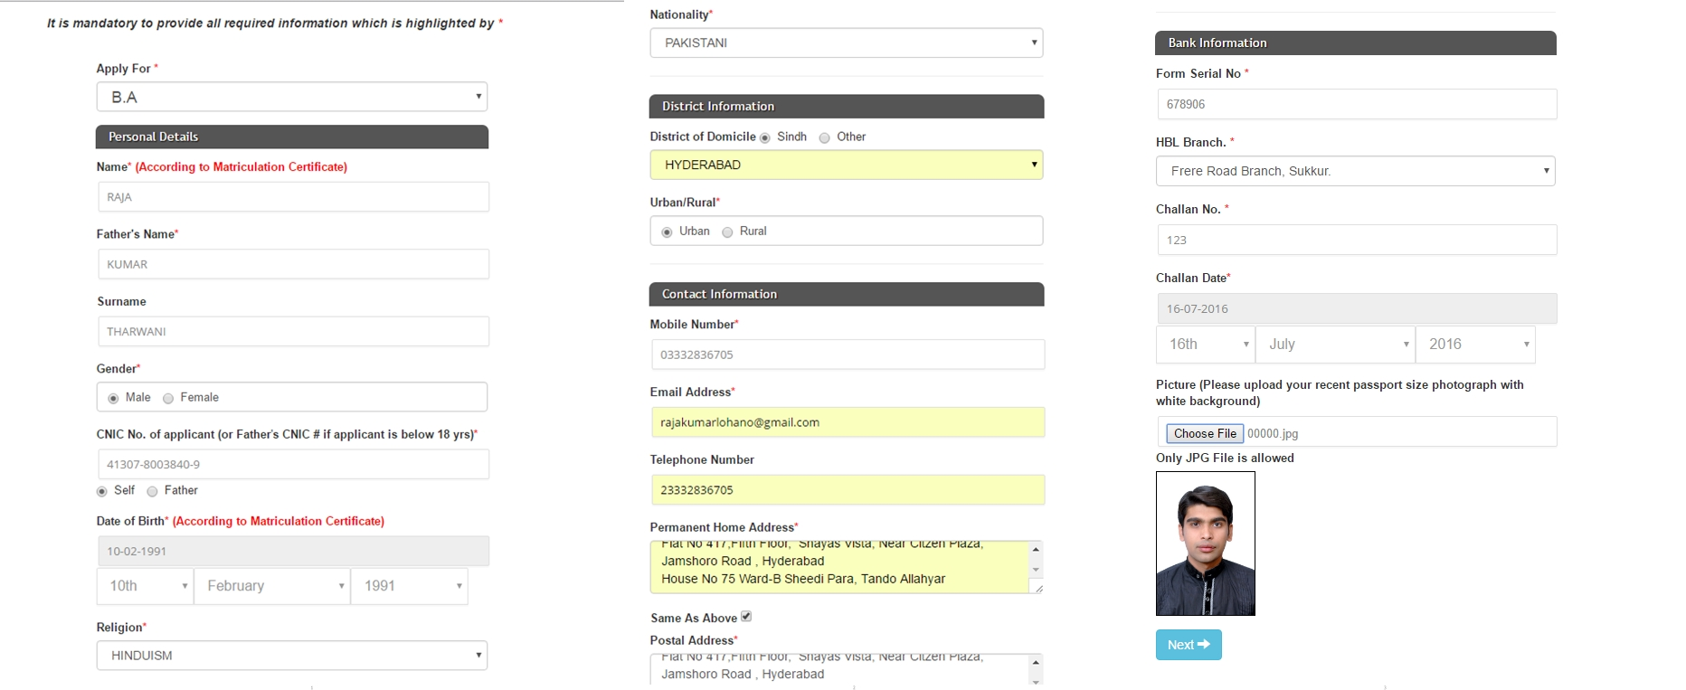

**Step3. Write down your Educational information**

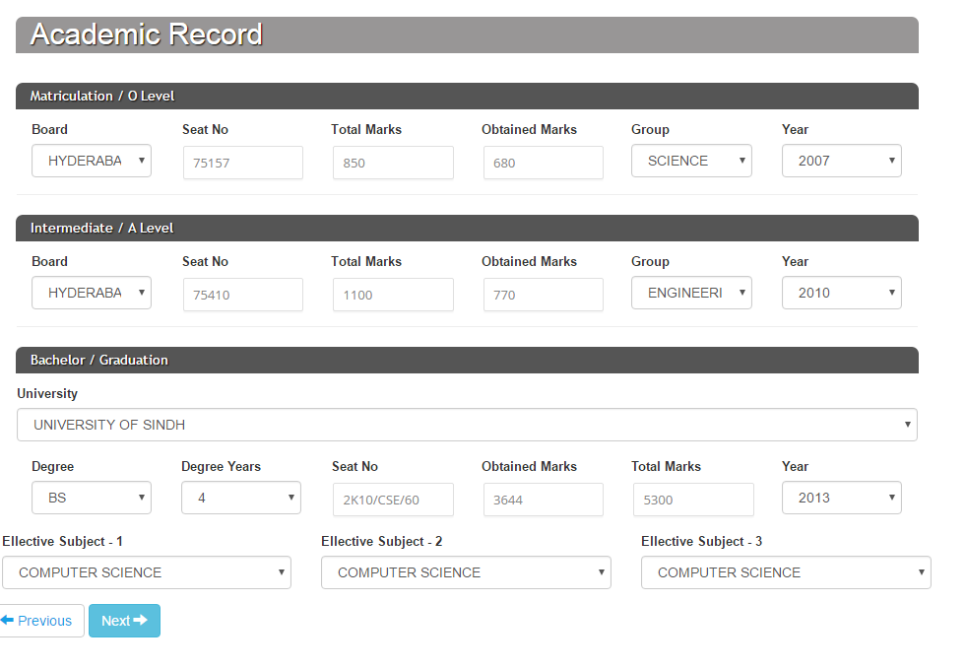

**Step 4. Select your collage and Discipline / Elective Subject**

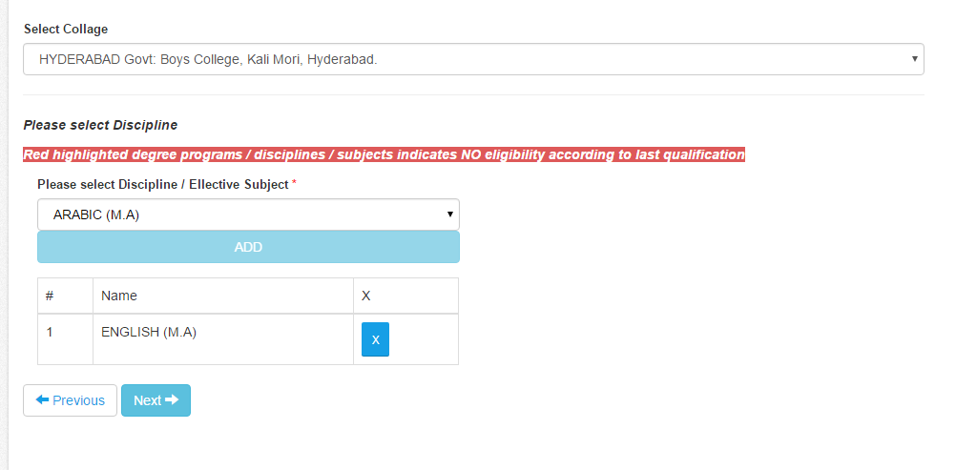

**Step 5. Review information**

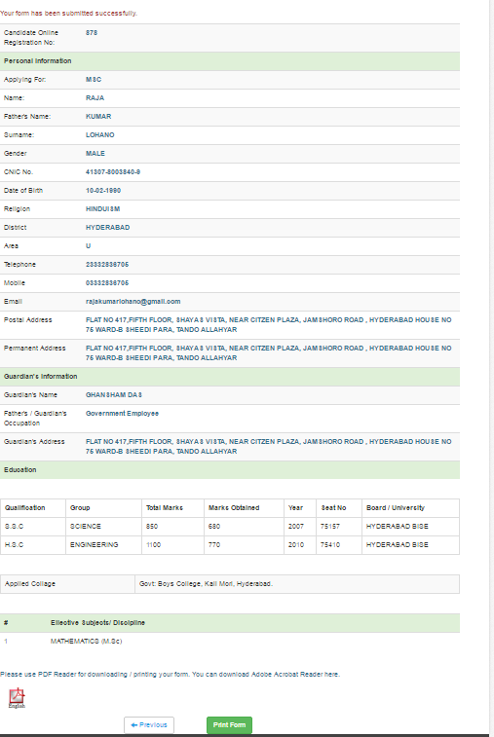

**Step 6. Print Form**

